**Practical No. 5**

Drag and drop a Dropdownlist control , add 2 listitems , Admin and NonAdmin, add a panel control , add server control as seen below (label to show you are an administrator and 3 textboxes) inside the panel control

**Note:** **set AutoPostBack property of Dropdownlist control to true.**

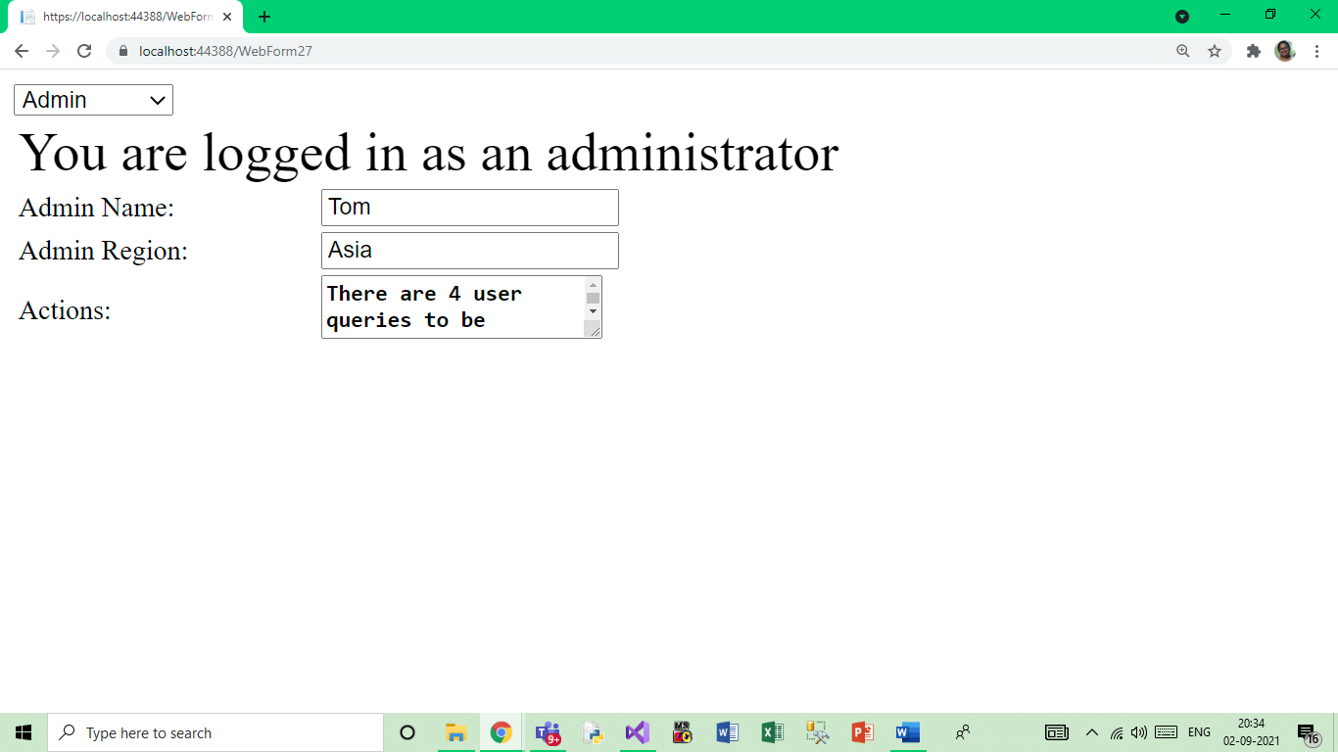

Add another panel control, add server control as seen below (label to show you are a non-administrator and 3 textboxes) inside this panel control.

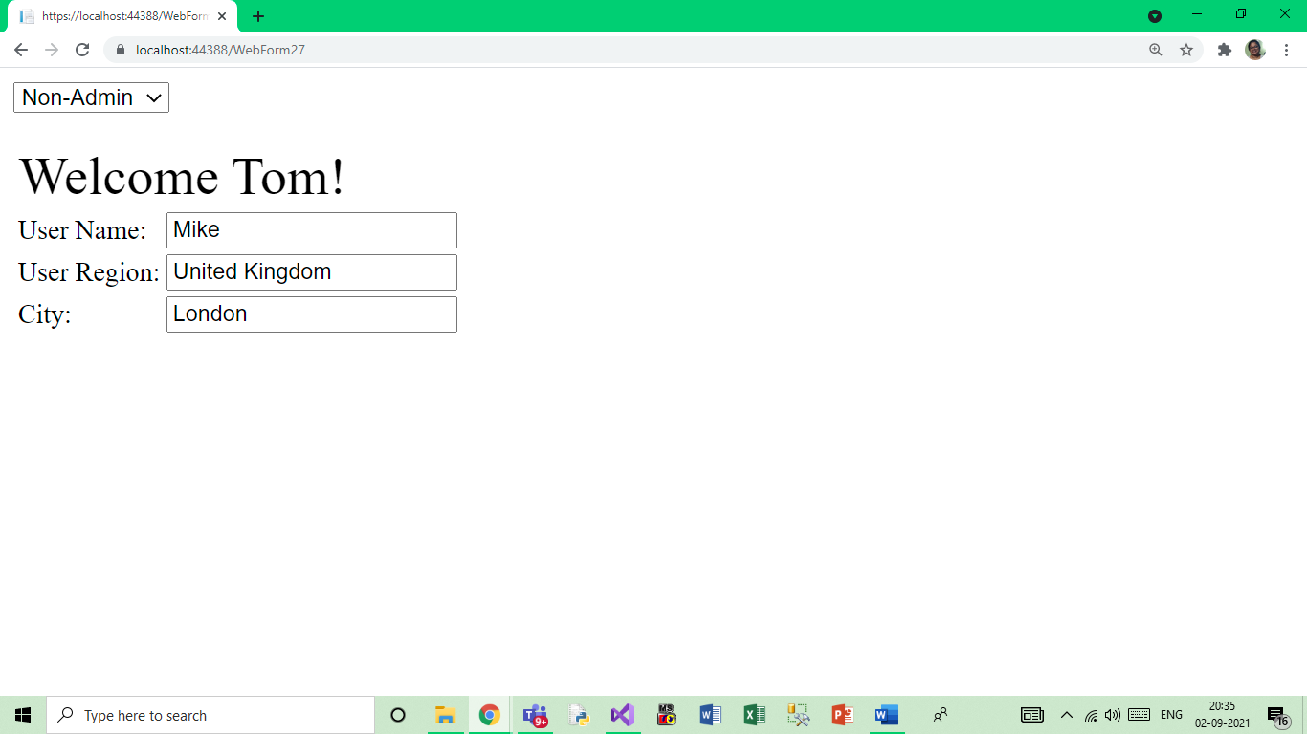

On selecting Admin in the dropdownlist the server controls in first panel should be seen.

On selecting Non-Admin in the dropdownlist the server controls in second panel should be seen.

Design a form as seen below and show the implementation.

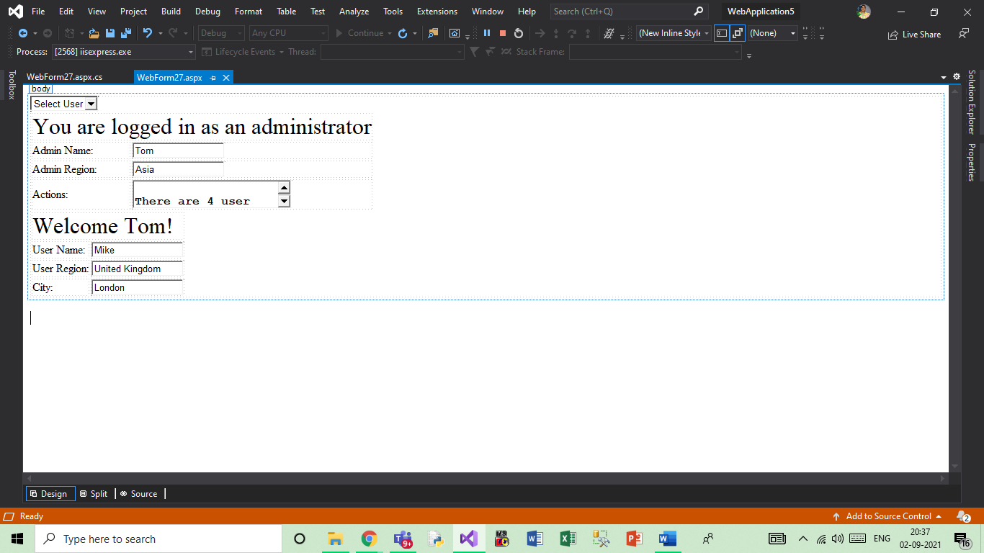

**.aspx**

<%@ Page Language="C#" AutoEventWireup="true" CodeBehind="WebForm2.aspx.cs" Inherits="WebApplication8.WebForm2" %>

<!DOCTYPE html PUBLIC "-//W3C//DTD XHTML 1.0 Transitional//EN" "http://www.w3.org/TR/xhtml1/DTD/xhtml1-transitional.dtd">

<html xmlns="http://www.w3.org/1999/xhtml">

<head runat="server">

<title></title>

</head>

<body>

<form id="form1" runat="server">

<div>

<asp:DropDownList ID="DropDownList1" runat="server" AutoPostBack="true"

onselectedindexchanged="DropDownList1_SelectedIndexChanged">

<asp:ListItem Text="Select User" Value="-1"></asp:ListItem>

<asp:ListItem Text="Admin" Value="Admin"></asp:ListItem>

<asp:ListItem Text="Non-Admin" Value="Non-Admin"></asp:ListItem>

</asp:DropDownList>

<asp:Panel ID="AdminPanel" runat="server">

<table>

<tr>

<td colspan="2">

<asp:Label ID="AdminGreeting" runat="server" Font-Size="XX-Large"

Text="You are logged in as an administrator">

</asp:Label>

</td>

</tr>

<tr>

<td>

<asp:Label ID="AdminNameLabel" runat="server" Text="Admin Name:">

</asp:Label>

</td>

<td>

<asp:TextBox ID="AdminNameTextBox" runat="server" Text="Tom">

</asp:TextBox>

</td>

</tr>

<tr>

<td>

<asp:Label ID="AdminRegionLabel" runat="server" Text="Admin Region:">

</asp:Label>

</td>

<td>

<asp:TextBox ID="AdminRegionTextBox" runat="server" Text="Asia">

</asp:TextBox>

</td>

</tr>

<tr>

<td>

<asp:Label ID="AdminActionsLabel" runat="server" Text="Actions:">

</asp:Label>

</td>

<td>

<asp:TextBox ID="AdminActionsTextBox" runat="server" Font-Size="Medium" TextMode="MultiLine"

Text="There are 4 user queries to be answered by the end of September 2023."

Font-Bold="True" ></asp:TextBox>

</td>

</tr>

</table>

</asp:Panel>

<asp:Panel ID="NonAdminPanel" runat="server">

<table>

<tr>

<td colspan="2">

<asp:Label ID="NonAdminGreeting" runat="server" Font-Size="XX-Large"

Text="Welcome Tom!">

</asp:Label>

</td>

</tr>

<tr>

<td>

<asp:Label ID="NonAdminNameLabel" runat="server" Text="User Name:">

</asp:Label>

</td>

<td>

<asp:TextBox ID="NonAdminNameTextBox" runat="server" Text="Tom">

</asp:TextBox>

</td>

</tr>

<tr>

<td>

<asp:Label ID="NonAdminRegionLabel" runat="server" Text="User Region:">

</asp:Label>

</td>

<td>

<asp:TextBox ID="NonAdminRegionTextBox" runat="server" Text="United Kingdom">

</asp:TextBox>

</td>

</tr>

<tr>

<td>

<asp:Label ID="NonAdminCityLabel" runat="server" Text="City:">

</asp:Label>

</td>

<td>

<asp:TextBox ID="NonAdminCityTextBox" runat="server" Text="London">

</asp:TextBox>

</td>

</tr>

</table>

</asp:Panel>

</div>

</form>

</body>

</html>

**.cs**

using System;

using System.Collections.Generic;

using System.Linq;

using System.Web;

using System.Web.UI;

using System.Web.UI.WebControls;

namespace WebApplication8

{

public partial class WebForm2 : System.Web.UI.Page

{

protected void Page_Load(object sender, EventArgs e)

{

if (!IsPostBack)

{

AdminPanel.Visible = false;

NonAdminPanel.Visible = false;

}

}

protected void DropDownList1_SelectedIndexChanged(object sender, EventArgs e)

{

if (DropDownList1.SelectedValue == "Admin")

{

AdminPanel.Visible = true;

NonAdminPanel.Visible = false;

}

else if (DropDownList1.SelectedValue == "Non-Admin")

{

AdminPanel.Visible = false;

NonAdminPanel.Visible = true;

}

else

{

AdminPanel.Visible = false;

NonAdminPanel.Visible = false;

}

}

}

}

**Output**

